Centennial college Progress campus

Comp 100

Assignment #03

Name: - Parth Chandgadhiya

Student no: - 300986134

Group: - 05

Formula One

**Quick Link: -** <http://rextester.com/OKUSQH87475>

**Formula One description: - Area of Triangle**

Calculating the area *T* of a triangle is an elementary problem encountered often in many different situations. The best known and simplest formula is:

{\displaystyle T={\frac {1}{2}}bh}

where *b* is the length of the base of the triangle, and *h* is the height or altitude of the triangle. The term "base" denotes any side, and "height" denotes the length of a perpendicular from the vertex opposite the side onto the line containing the side itself.

**Formula One Flowchart: -**



**Formula One C# Code:**

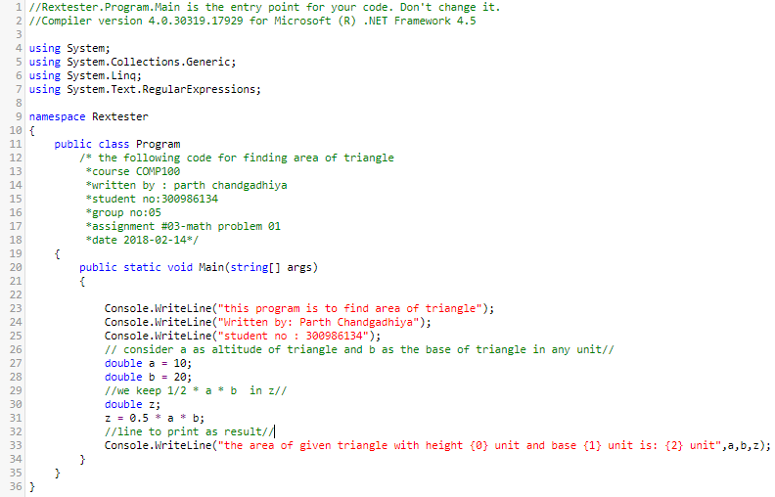

**Formula one Output screenshot: -**

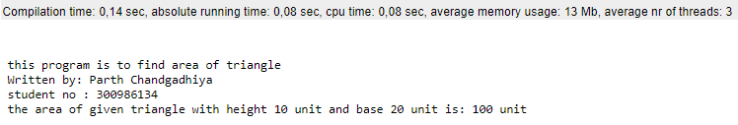

Formula Two

**Quick Link: -** <http://rextester.com/MQUN63542>

**Formula two description: - Weight on Different planets of solar system.**

To calculate the weight on other planet, we need gravity index of required planet to convert our weight on earth into the weight on any other planet. For this gravity of earth is considered as 1 and the gravity of other planet is referred by considering the ratio of gravity of earth to the gravity of another planet.

$$w_{0}=w_{e}⋅g$$

Where $w_{0}$ is weight on other planet, $w_{e}$ is weight on earth and g is gravitational index

**Formula Two Flowchart: -**



**Formula Two C# Code:**

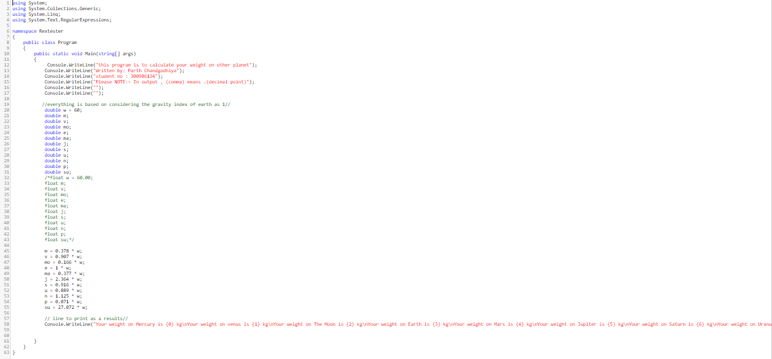

**Formula Two Output screenshot: -**

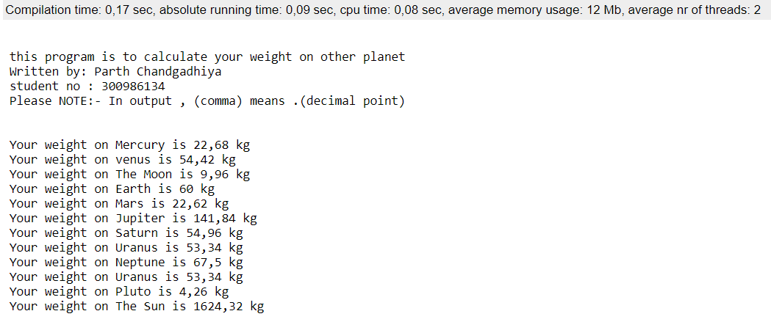

Formula Three

**Quick Link: -** <http://rextester.com/FOELCJ96024>

**Formula Three description: - Volume of square based Pyramid**

In geometry, a **square pyramid** is pyramid having a square base. If the apex is perpendicularly above the center of the square, it will have *C*4v symmetry. For square pyramids in general, with base length *b* and height *h*, the surface area and volume are:

$$V=\frac{b^{2}h}{3}$$

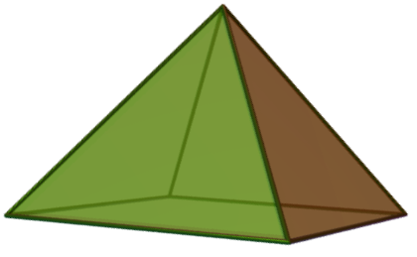

**Formula Three Flowchart: -**



**Formula Three C# Code:**

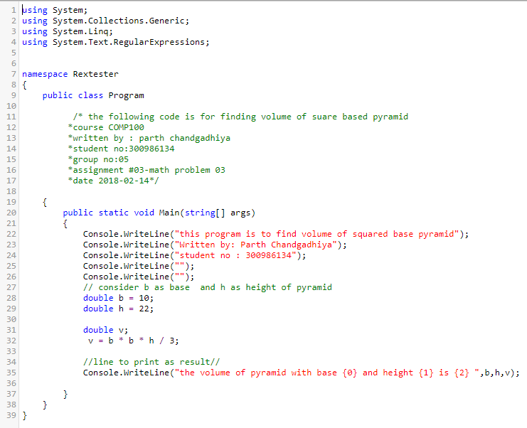

**Formula Three Output screenshot: -**

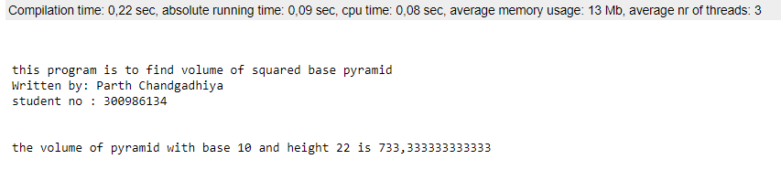

# **Reference: -**

[01]

https://en.wikipedia.org/wiki/Triangle#Computing_the_area_of_a_triangle

[03]

https://en.wikipedia.org/wiki/Square_pyramid